Lummi Transit Weekend Schedule
*Transit appreciates your patience as we work to add the weekend service to the Transit Map.

Route A Lummi Reservation
Saturday and Sunday Service

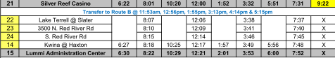

Please note that Lummi Transit will begin the route at 8:01am at the Silver Reef Casino and will end at 3:53pm at Lummi Administration Center.

